**FUND RAISER FOR IET LUCKNOW STUDENTS**

**A**

**B**

**O**

**U**

**T**

**U**

**S**

**OUR MISSION**

**OUR VISION**

H

I

S

T

O

R

Y

***Let’s become a helping hand for them…***

**CONTACT DETAILS -**

***ASHISH MAURYA***

***CSE (2020-2024)***

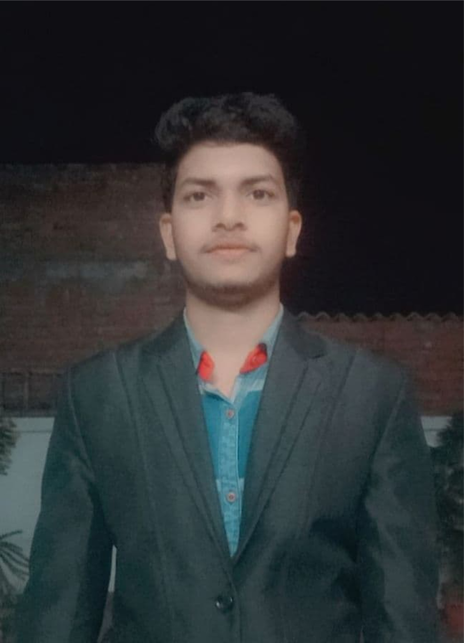

***YASH TRIPATHI***

***CHE (2019-2023)***

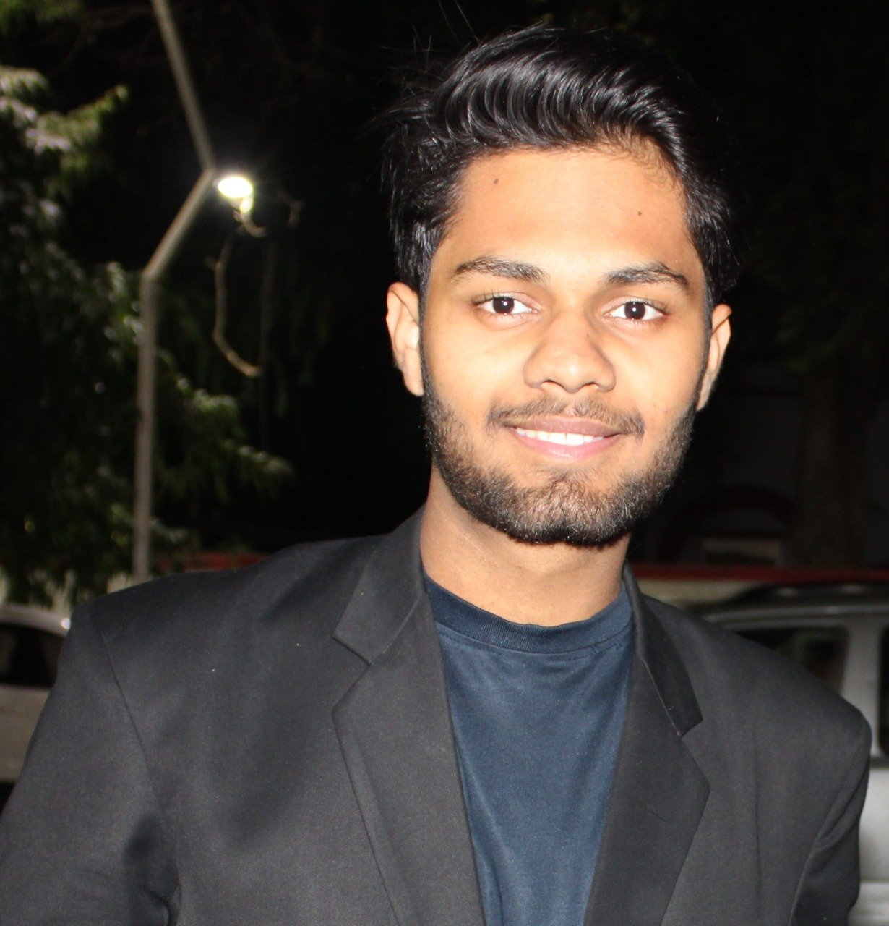

**THEY NEED OUR SUPPORT**

This platform enhanced my academic grade point, strong character development, and also to afford study material for UPSC preparation. I am highly thankful for this great initiative.

***ABHISHEK TRIPATHI***

***EI (2018-2021)***

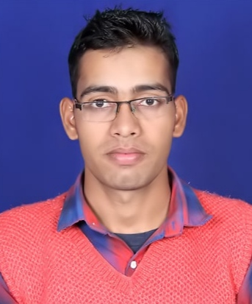

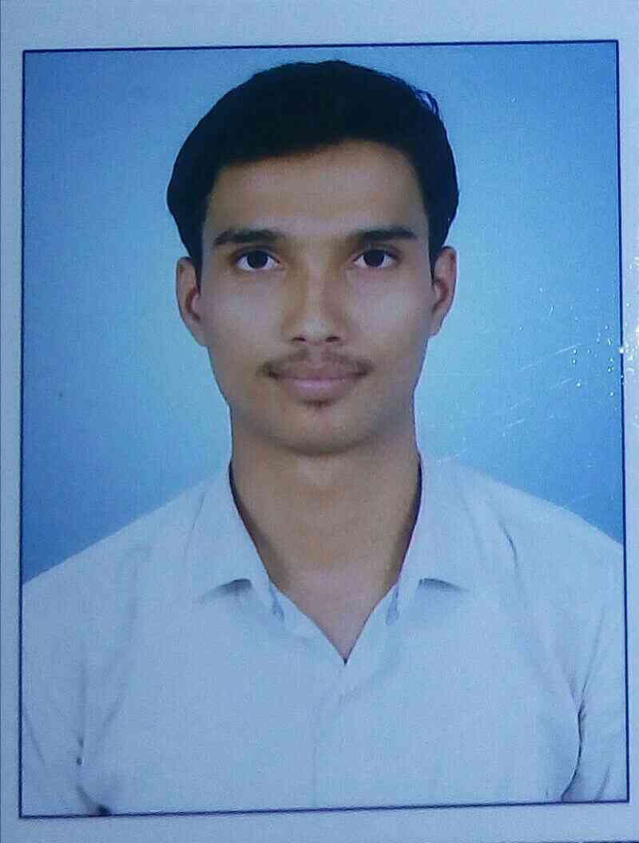

***SURYA PRAKASH TIWARI***

***EI (2018-2021)***

हैलो, मेरा नाम सूर्य प्रकाश तिवारी है। मैंने अपना B. Tech पिछले वर्ष 2021 मे पूर्ण किया। मेरी आर्थिक स्थिति ठीक न होना, इंटरमीडिएट के बाद मेरी पढ़ाई के लिए एक खाई जैसा था। लेकिन EVOLVE ने मेरा पूरा साथ दिया। मेरी पढ़ाई की फीस, रहने का, खाने – पीने का खर्च सबमें हमारी मदद की। यहां तक की किताब – कापी लेने में हमारी मदद की। मैं EVOLVE को तथा उन सभी को धन्यवाद देता हूं, जिन्होंने मेरी किसी भी तरह से मदद की।

धन्यवाद।

सूर्य प्रकाश तिवारी

***ASHAKANT SAINI***

***EC (2017-2021)***

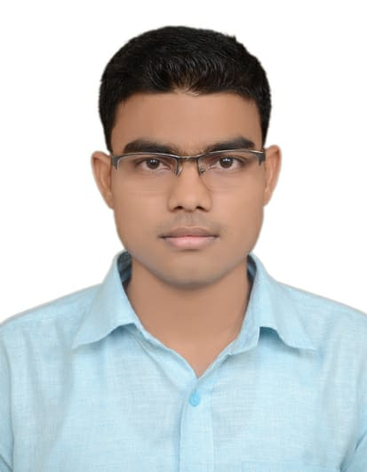

Whenever I have financial issues, This NGO and their volunteers had helped me a lot.

Actually I belong to a very poor family background.....

So giving fees to my college, living outside and purchasing books, these were very difficult for me to manage them financially. But when I came in touch of this NGO, they helped me a lot financially as well as emotionally also.

I am very much thankful to them and their supporting volunteers.

And now I am working in Wipro and supporting many students of my college who are like me only when I was in college.

**OUR SUCCESS STORIES**